# CASPRS ver 2.1 user guide

## The download of software and sample file

Computer-aided shoreline position recognition software (CASPRS) is a software used to recognize the shoreline position on satellite images. The software and sample files can be download from the https://github.com/ouczxd/CASPRS.

## The data files

The software is stored in an EXE file, which is named as CASPRS 2.1.exe. The file can be run on Windows 10 without install.

The data of CASPRS is separated to two parts: the shoreline position data and satellite images. The shoreline position sample data is named as “Feng River sample.zip”, and it contain 3 parts: the CAS file, the CSV file, and the images.

The satellite images sample data is reduced to 11, since the original 812 images are too big to be uploaded to the GitHub. All the satellite images can be downloaded from Google Earth Engine (https://earthengine.google.com/) using the program: “GEEdownloader” (https://github.com/ouczxd/CASPRS).

## Start of the CASPRS

(1) Just double-click the CASPRS 2.1.exe, then you open the open file main window.

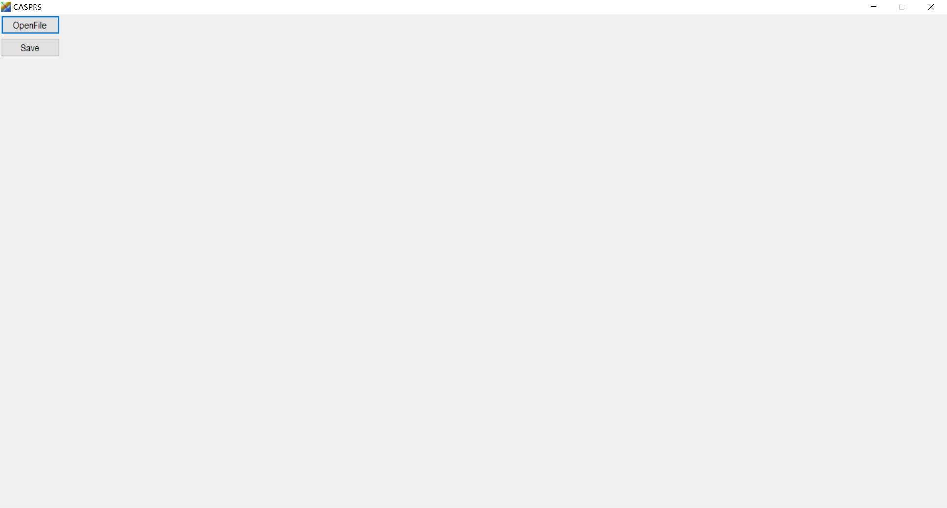

Figure 1 the open file window of CASPRS

(2) click the Openfile button to open the open CAS file dialog.

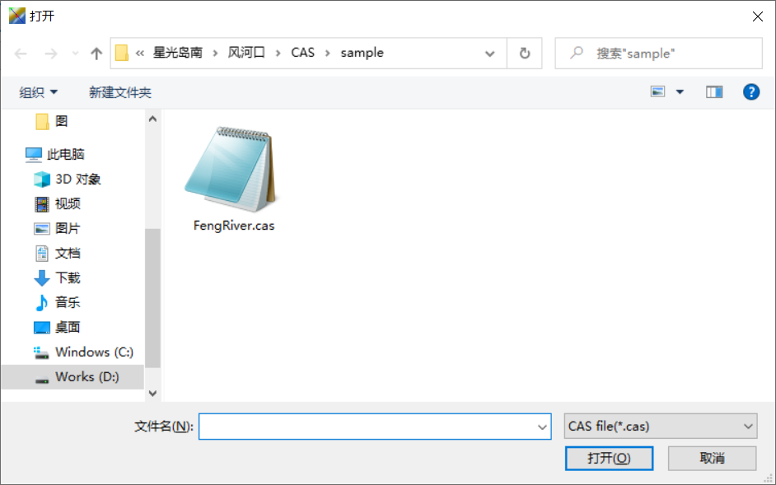

Figure 2 open CAS file dialog

(3) Browse to your directory storing the *.cas, and select the CAS file you want to work with, such as the FengRiver.cas, then click the Open button.

It should be noted that the CAS file, the CSV file and the Satellite image files should be stored in the same directory, and the CAS file and the CSV file should have same name.

(4) Here, you opened the main window of CASPRS.

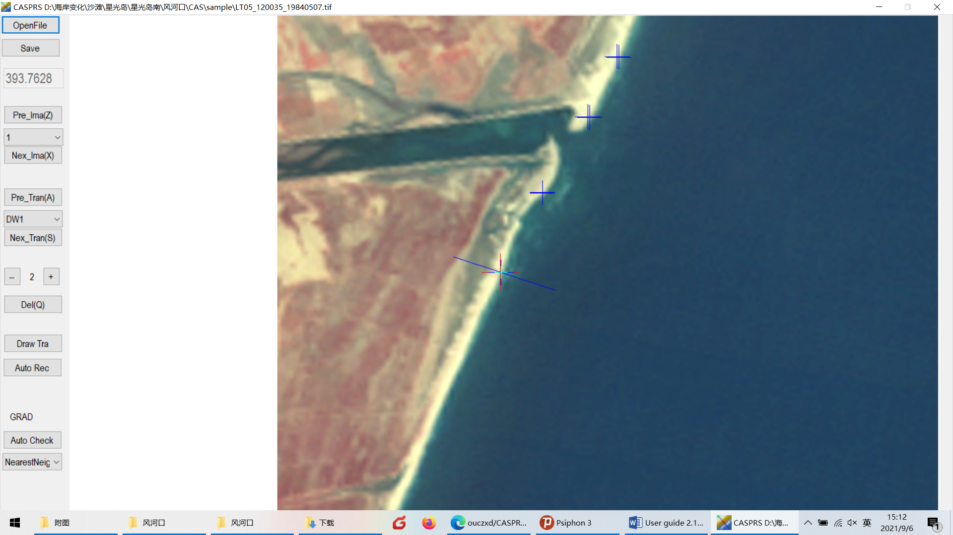

Figure 3 Main window of CASPRS

## Operation of CASPRS

You can switch between images by click the Pre_Ima and Nex_Ima buttons, or press “Z” and “X” keys; you can also switch between transects by click the Pre_Tran and Nex_Tran buttons, or press “A” and “S” keys. The image can be zoomed at the rates of 1-30 by click the Zoom in (-) and Zoom out (+) buttons. You can also create an image plotted the transects on the current image.

When you are recognizing the water lines, you can click the Auto Rec button to let the software to find the possible positions of the water lines on the current transect.

The Save button is their text meaning.

If you think the shoreline position is not right, you can click on the right position on the images, and CASPRS calculated the foot point of the right position on current transect. If there is no right position, you can delete the current result by click the Del button.

I recommend that you identify the shoreline positions in the order of the transects. Firstly, click the Auto Rec button, and then check the results. When switch between the images, I recommend you press X key to move to next image, and use the mouse to click the right position if it is wrong, or click the Del button if there is no right position.